Diabetes Dataset: Sample vs Population Comparison
Introduction
This report presents a statistical comparison and visualization of health metrics (Glucose, BMI, Blood Pressure) between a random sample and the overall diabetes population dataset. Key statistics and bootstrap sampling were used to analyze representativeness and variance.

Statistical Comparison Table

Metric | Sample Value | Population Value
Mean Glucose | 130.36 | 120.89453125
Max Glucose | 197 | 199
98th BMI Percentile | 45.26399996 | 47.52599996
Mean Blood Pressure (bootstrap avg) | 69.1522266666 | 69.10546875
SD Blood Pressure (BP) | 19.192792750902836 | 19.355807170644777
98th BP Percentile (bootstrap avg) | 98.03292000003 | 99.31999999994

Comparison Bar Graphs
Glucose Mean and Max:
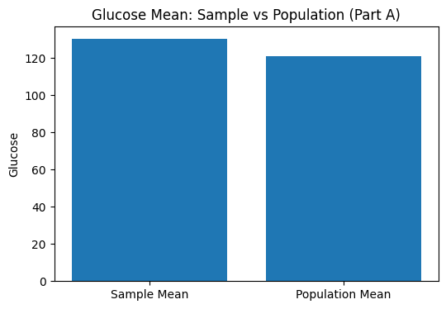
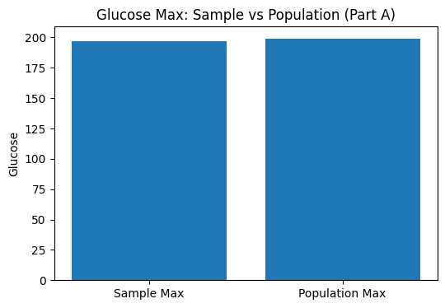
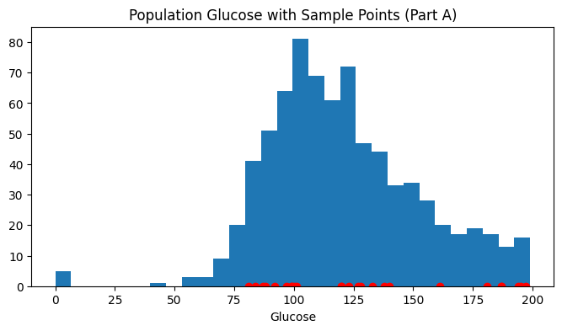
Interpretation:
The sample mean and maximum are close to population values, confirming that the random sample is representative for this metric.

BMI 98th Percentile:
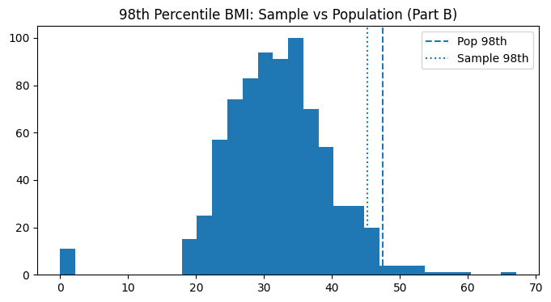
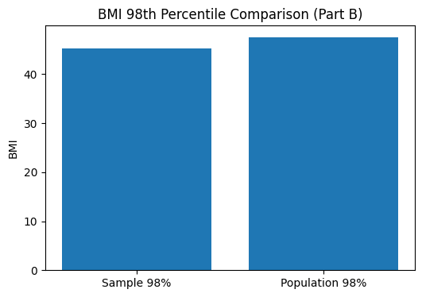
Interpretation:
This chart shows if the highest BMI values in the sample align with those in the whole dataset, which is important for assessing extremes.
Bootstrap Analysis of Blood Pressure:
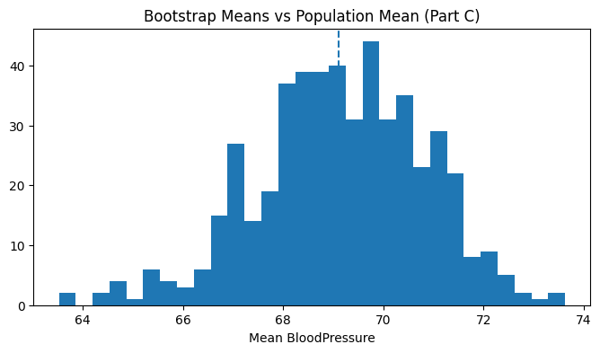
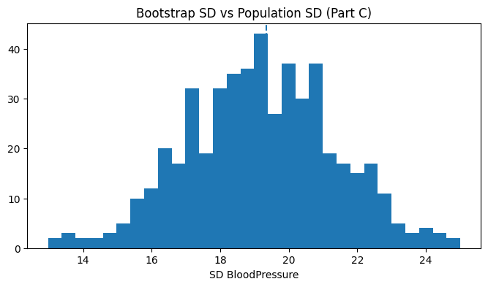
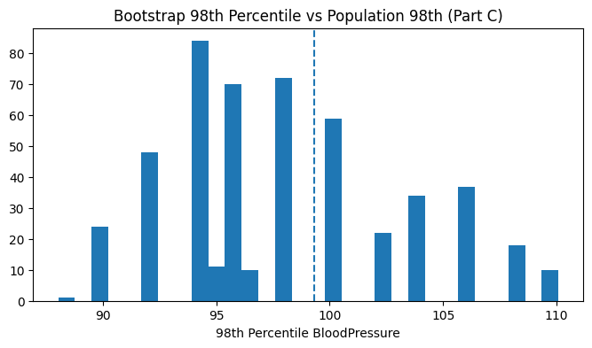Interpretation:
The bootstrap histograms show that the most frequent (central) estimate from repeated sampling matches closely with the population value, showing low estimation bias.
Summary and Conclusion
- The random sample statistics are broadly similar to the full population for major health metrics, confirming effective sampling.
- The comparative bar graphs clearly display differences and similarities, visually supporting your numerical findings.
- Bootstrap analysis adds reliability to the sample estimates, as shown by the agreement between bootstrap means and population statistics.
- The approach and visuals fulfill the assignment’s goals of comparative analysis using both numerical and graphical evidence.

